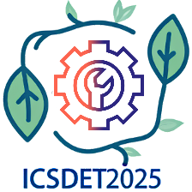

ICSDET 2025
International Conference on Sustainable Development in Engineering and Technology, 2025
April 30th and May 1st, 2025
ICSDET2025 Technical Advisory Committee Members:
- Dr. Thangam Palaniswamy
Associate Professor,
Department of Electrical and Computer Engineering,
Faculty of Engineering,
King Abdulaziz University,
Jeddah, Saudi Arabia

- Dr. Rani Jabbar
Assistant Professor
Department of EDICT,
Electrical Engineering section,
Bahrain Polytechnic,
Isa Town,
Kingdom of Bahrain.

- Dr. Mahendiran Vellingiri
Assistant Professor
Department of Electrical and Computer Engineering,
Faculty of Engineering
King Abdulaziz University,
Jeddah, Saudi Arabia

- Dr. M. Ramkumar Raja, Associate Professor,
Department of Electrical Engineering,
College of Engineering,
King Khalid University,
Abha, Saudi Arabia

- Dr. Godi Karunakar
Associate Professor
Electrical Electronics and Communication Engineering
GITAM School of Technology, India

- Dr. B. Murali Krishna
Professor & Principal
Avanthi Institute of Engg. &Technology,
Bhogapuram,
Vizianagaram, AP, India

